Grizzwalk Demonstration

On starting the app, the user will be brought to the Class List screen, where the user’s classes will be displayed. If the user had entered classes in a previous run of the app, they are displayed on launching the app.

This is the “center” of the app; any other screen in the app can be accessed from just one tap on this screen.

The Calendar View and Get Building Directions buttons on the top take the user to those respective activities. The Clear Classes buttons clear the Class List of all of its classes.

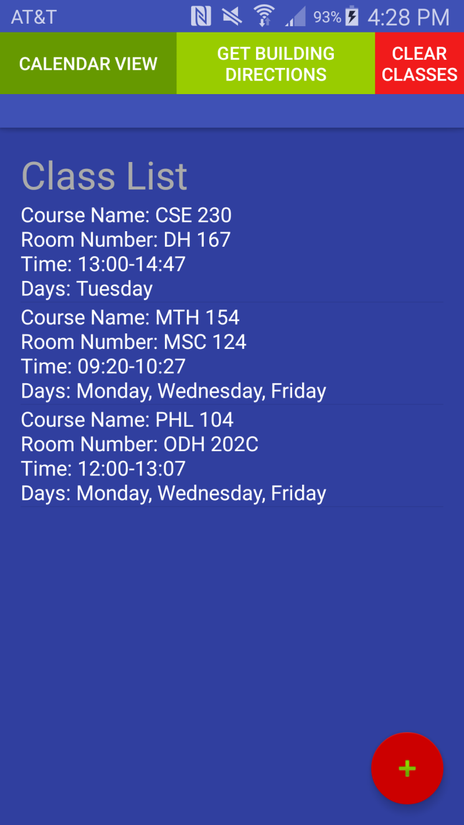Pressing the + button in the lower right corner takes the user to the add class screen.

On the Add Classes screen, the user can input class information to be added to the Class List.

The Add Class button adds the class into the class list if the user has provided all the relevant information. If they have not entered information in all fields, the class will not be added. In the first screenshot, the user tries to add the class without filling out all the necessary information, and the class is not added. Once a class is added, the user is automatically taken back to the Class List page.

The Reset Fields button clears all the EditTexts and checkboxes in the activity.

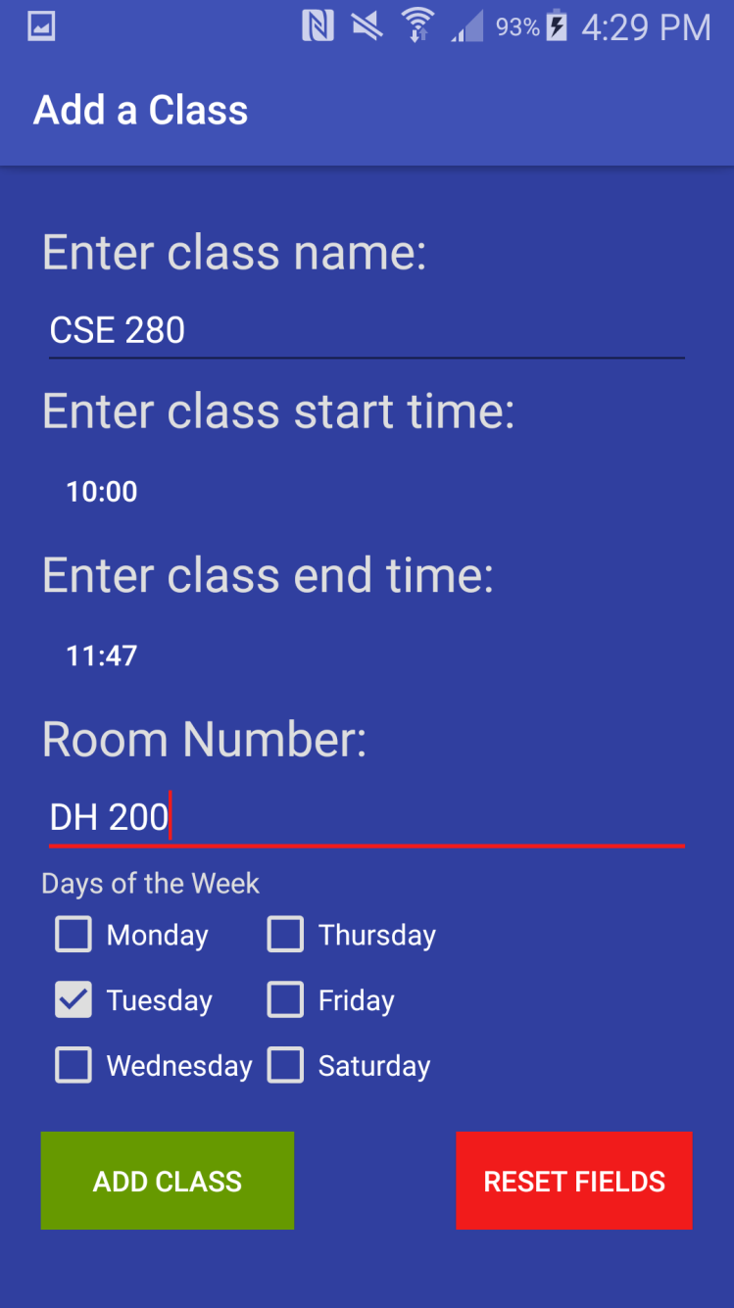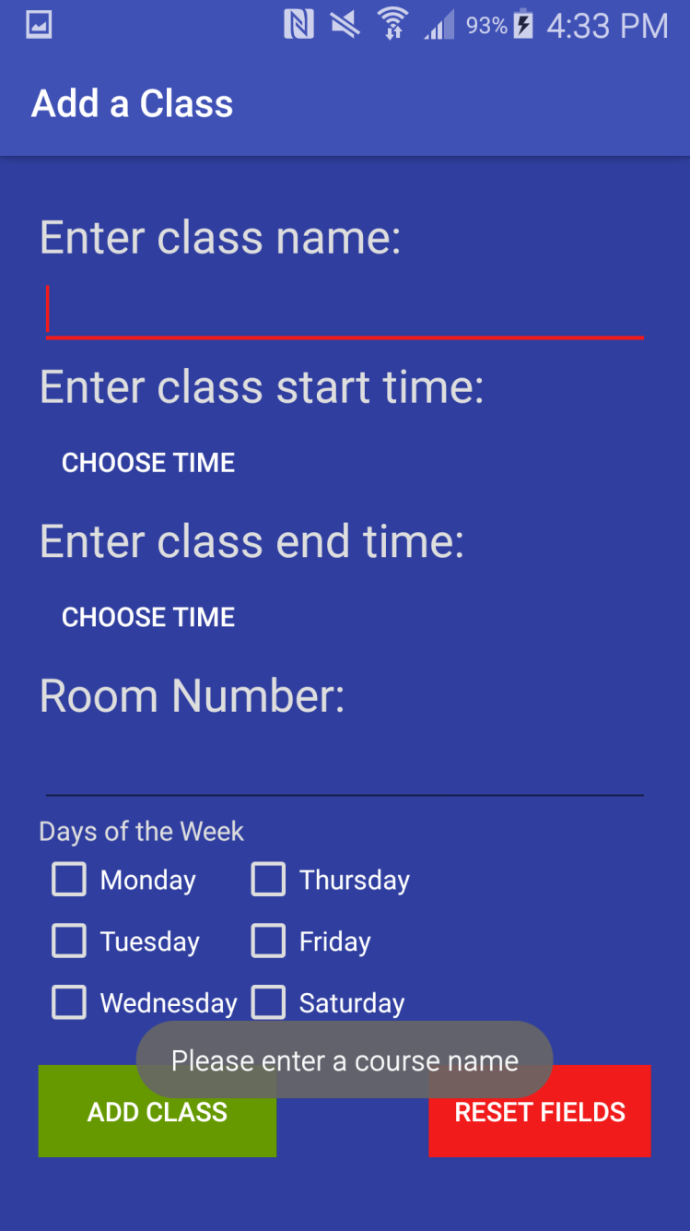

The Class List is updated to reflect the added class.

Clicking the Calendar View button allows the user to see their classes in another way.

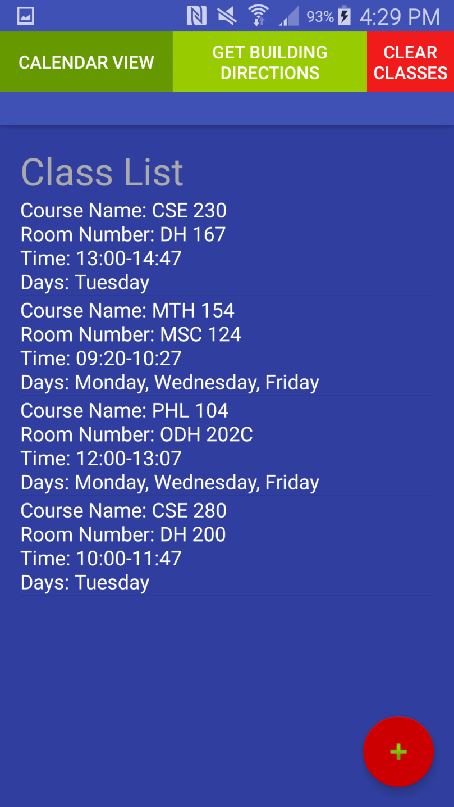

The user can tap any day on the calendar, and see what classes they have that day with the list on the bottom. Nothing will show up in the list if the user has no classes that day.

Clicking the Add Exam button allows the user to set a reminder for an upcoming exam on a specific date and time. A notification will be sent to the notification bar at the noted time, even if Grizzwalk is not up.

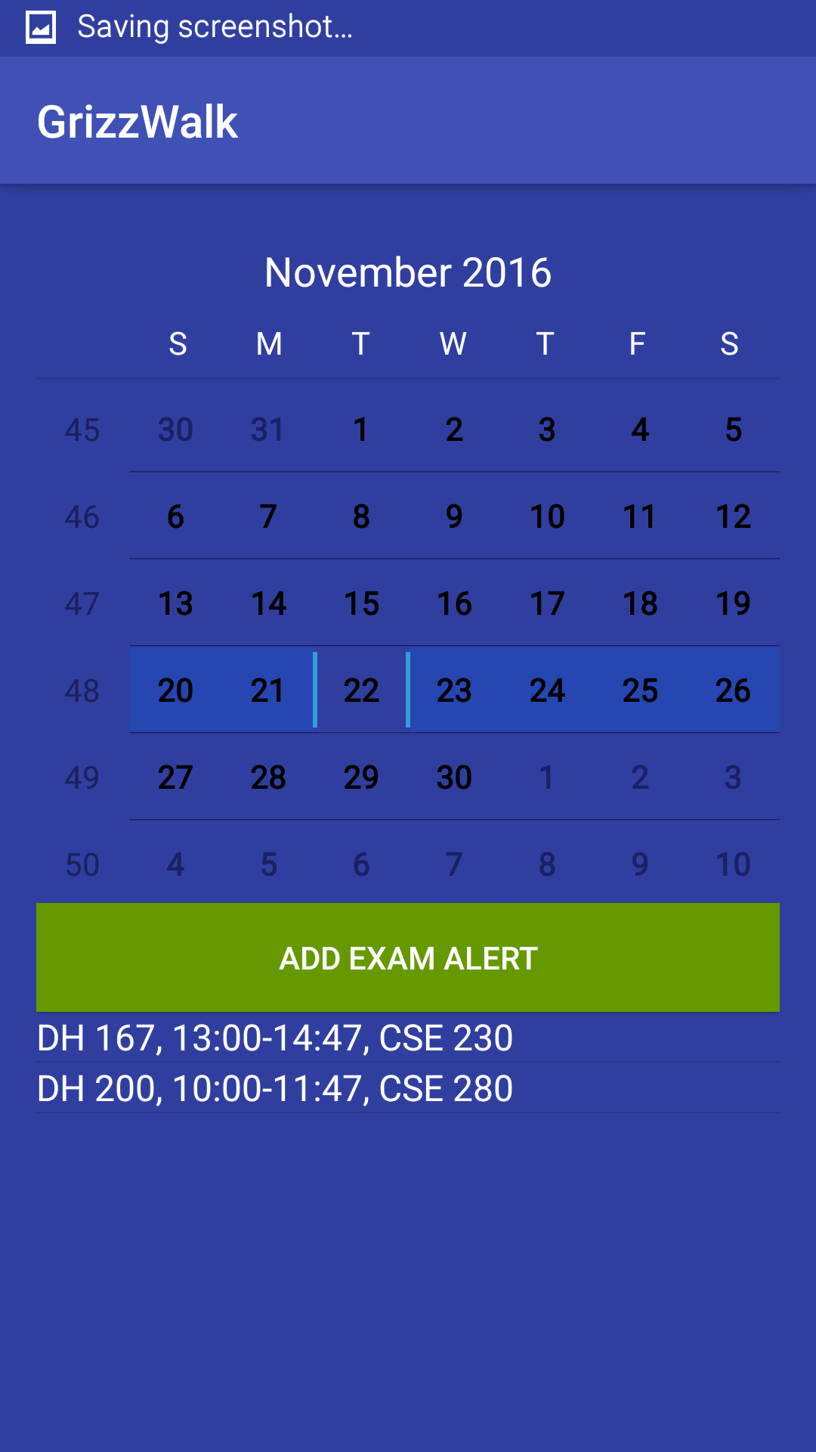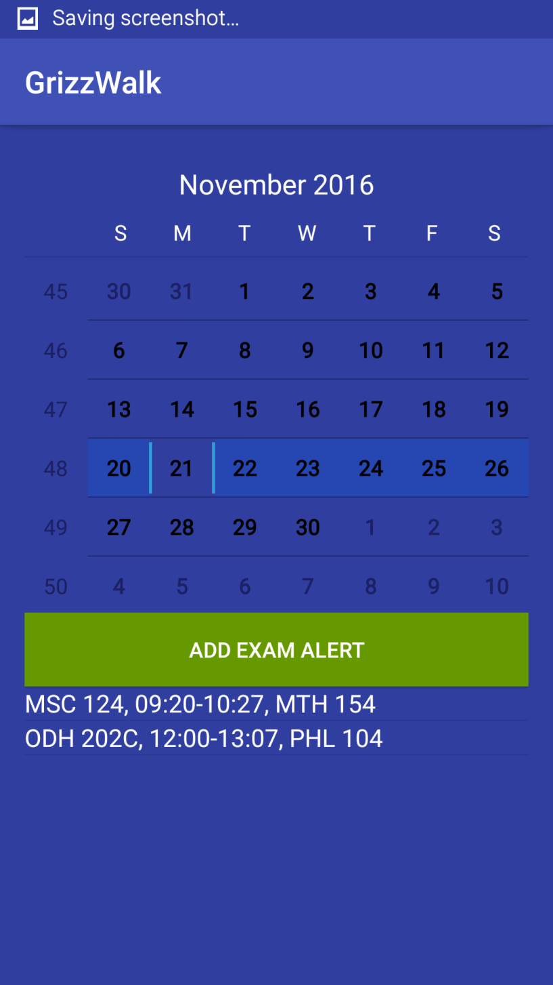

An example of the alert feature using a different schedule. Once the user clicks the Add Exam Alert button, they are prompted to choose a class from the ones taking place on the selected day, and how long before that class they would like to be reminded.

Below is an example of the user setting an alert for six hours before the selected class,

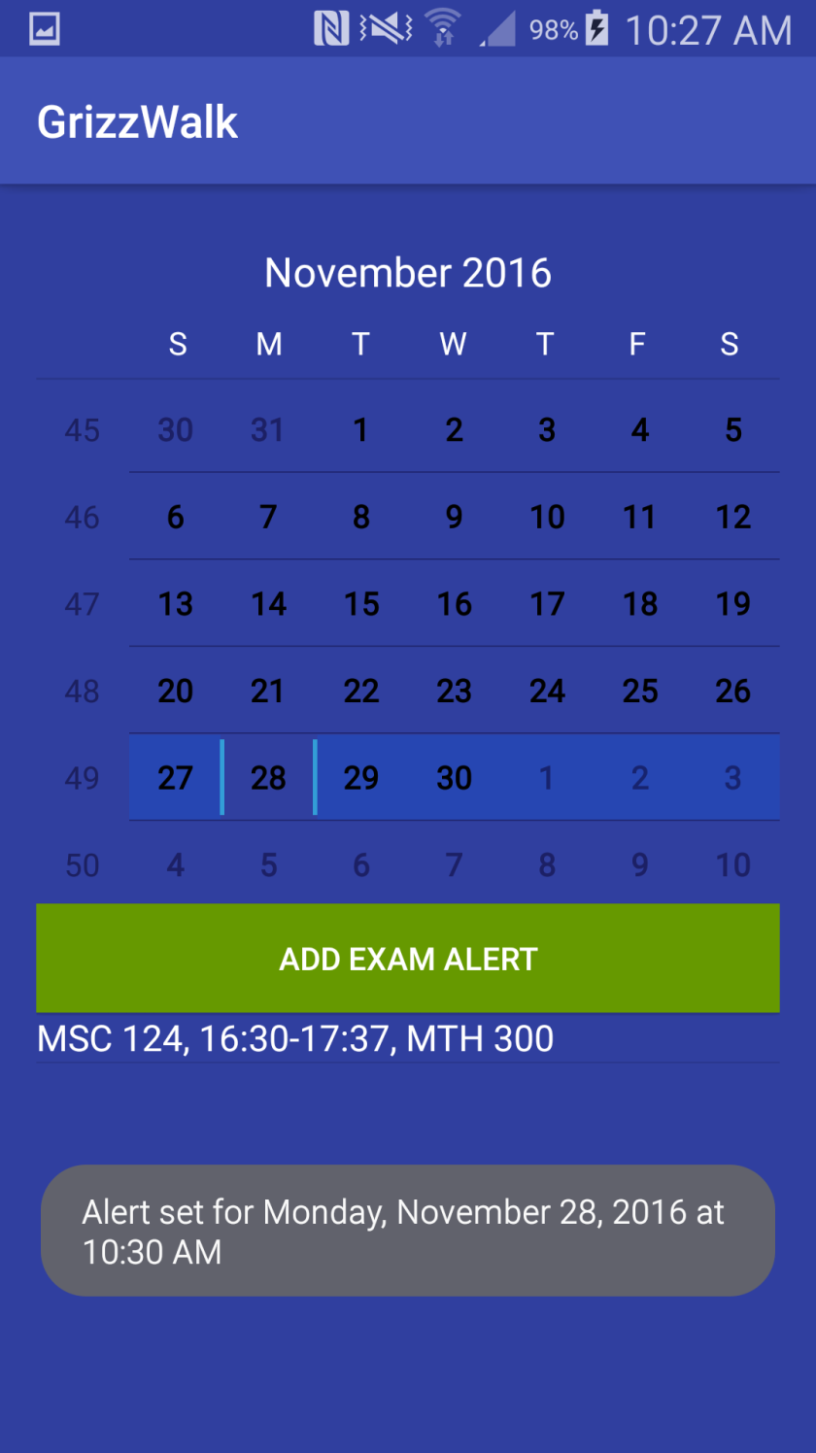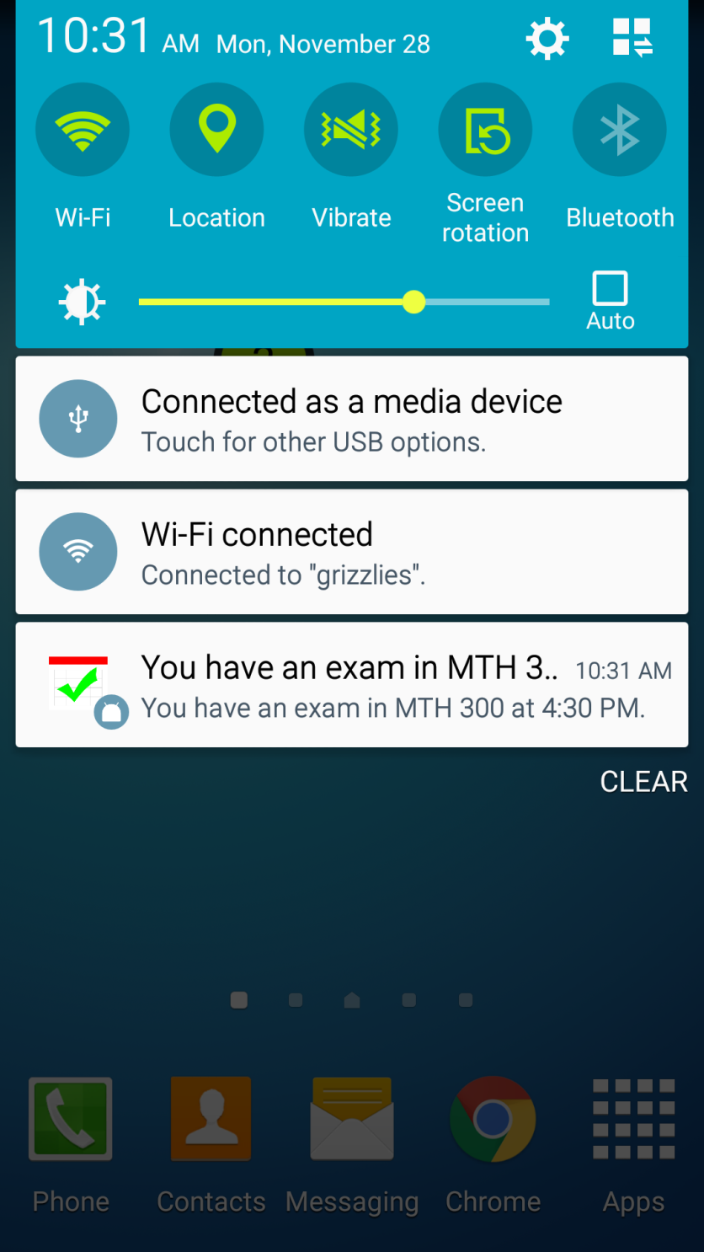

Clicking the Get Directions button on the Class List Activity brings the user to this screen, where the user can enter two buildings on campus and get a list of directions on how to navigate from one to the other

Nothing happens but a Toast message if either destination is invalid, or the user tries to enter in the same building for both fields.

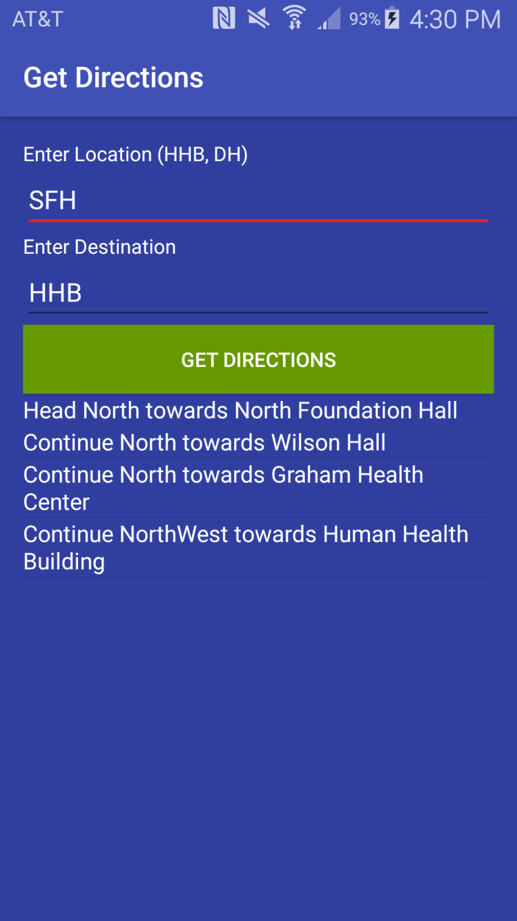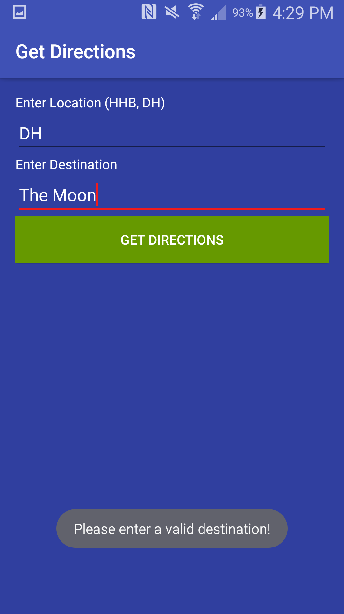

The Clear Classes button will ask the user if they’re sure they want to clear their classes. If the user answers yes, then all classes in the Course List are cleared.

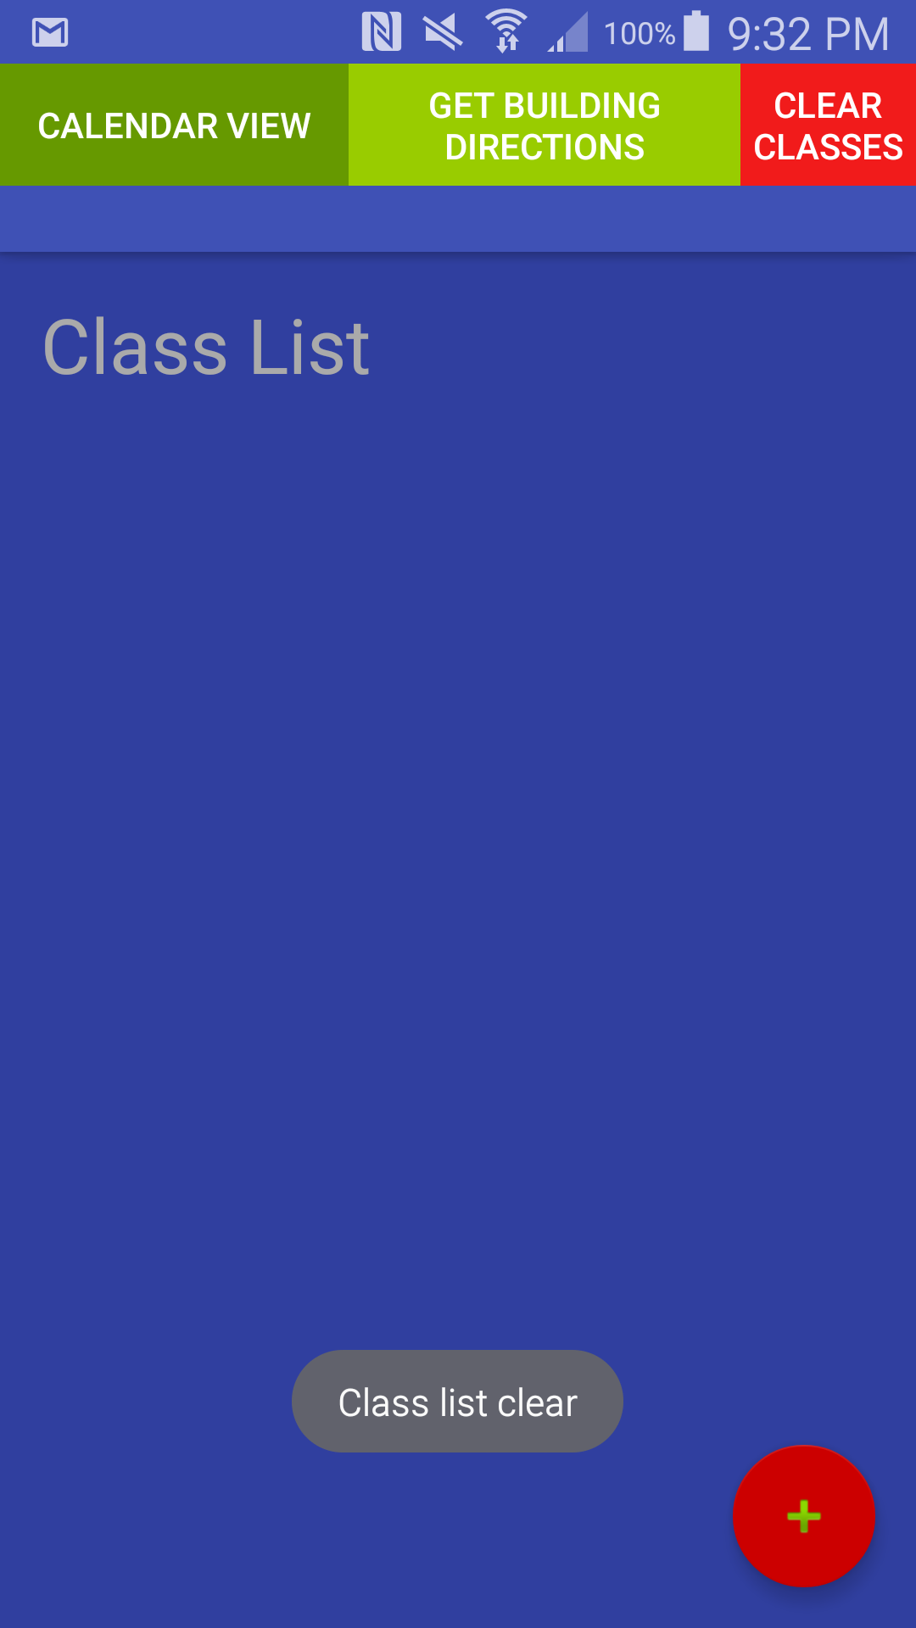The Clear Classes button is smaller than the rest of them since the user should be pressing that button the least out of the three buttons on the toolbar.